How to create Email Send List..

- Start Wampp server.
- Goto following url:http://localhost/iaacpommo/index.php and login with admin details.

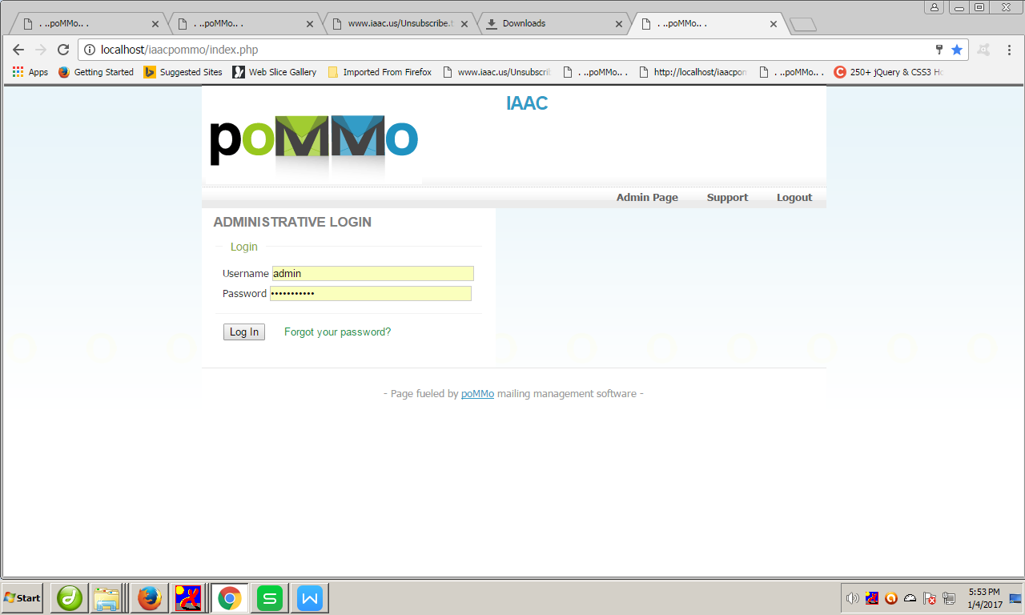

3.Select Subscribers => manage
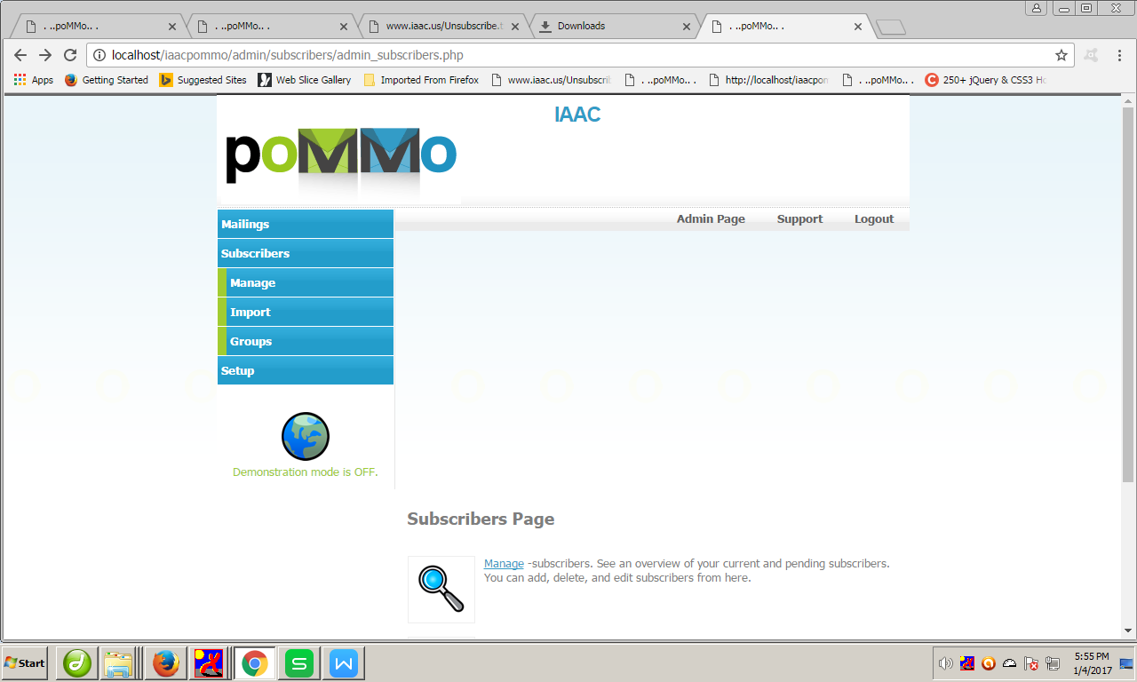

- Select Export subscripers
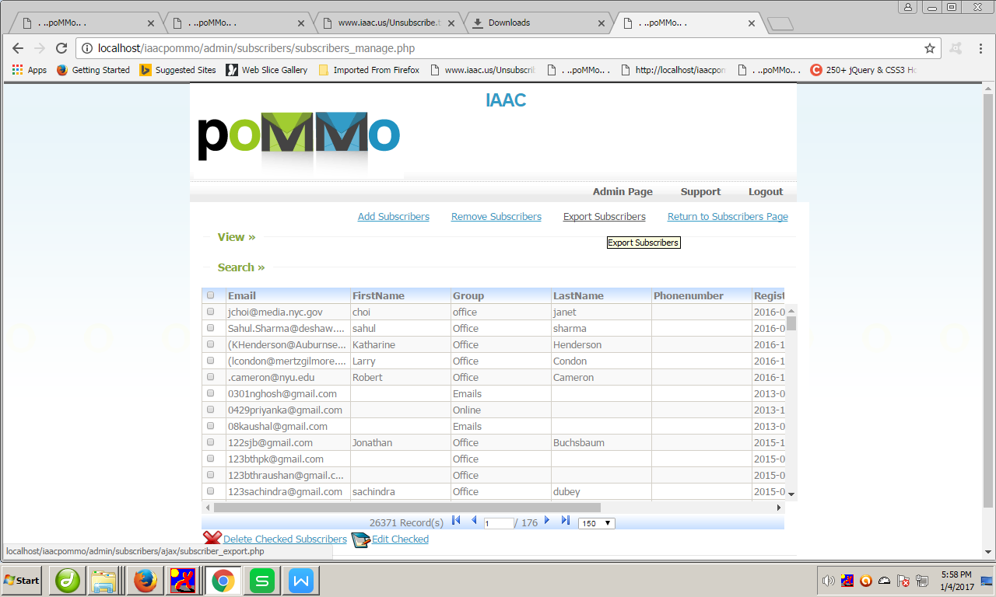

Choose => type=”.cvs ” click on export button
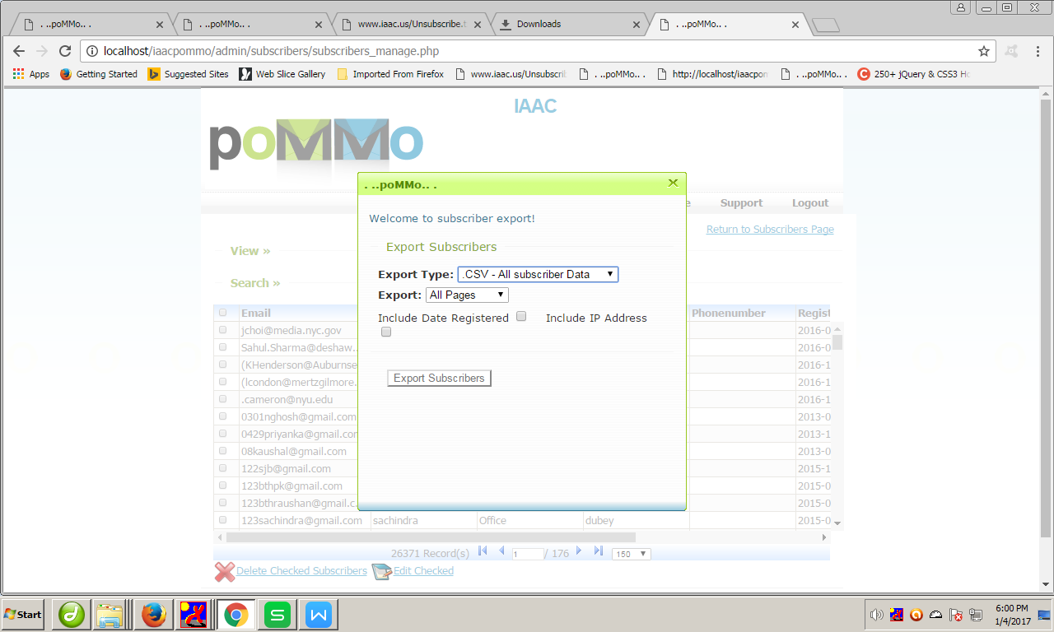

- A downloading file exported file with open.In that you have to select Groups then click on filter auto menu from Home tab Like:
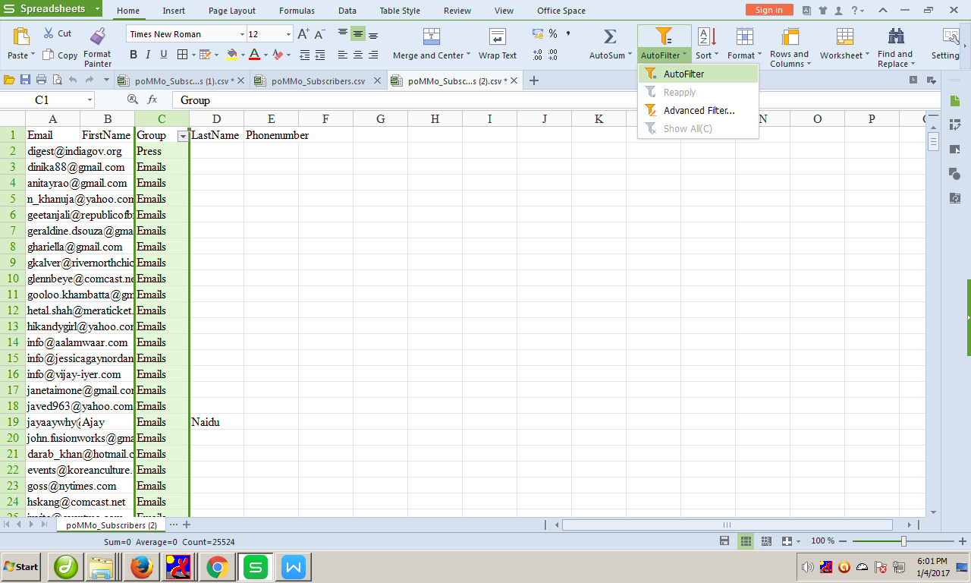

Checkbox checked that you wanto select:
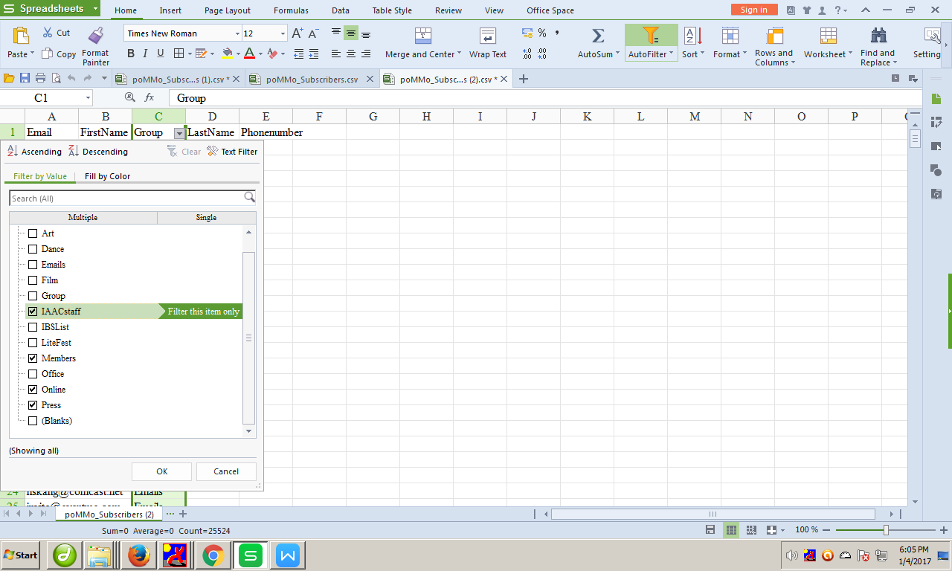

- Create a new file with “target_email.txt” name.
Past staff group emails into that.
priority(staff/member/ press/others).

- Put gartet_email.txt file into:D:\wamp\www\iaac-mailing-list

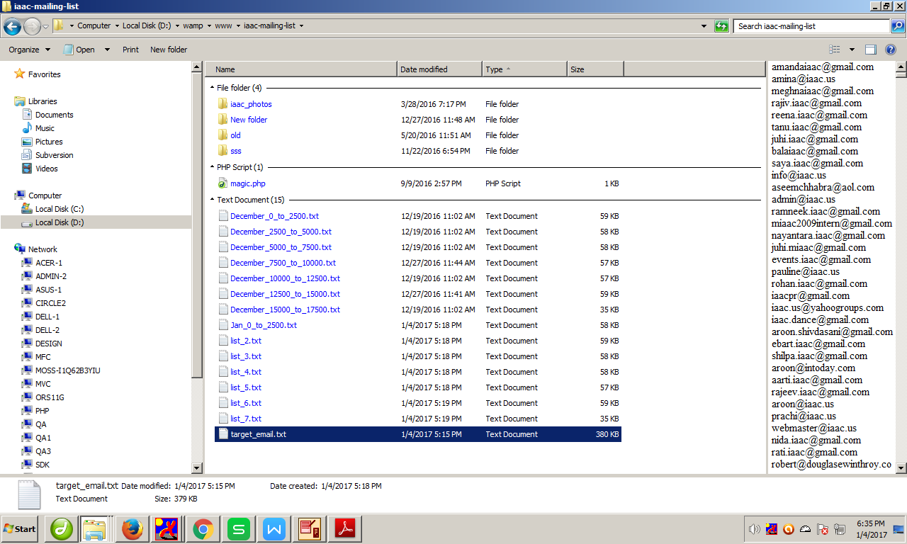

- Goto : http://localhost/iaac-mailing-list/magic.php

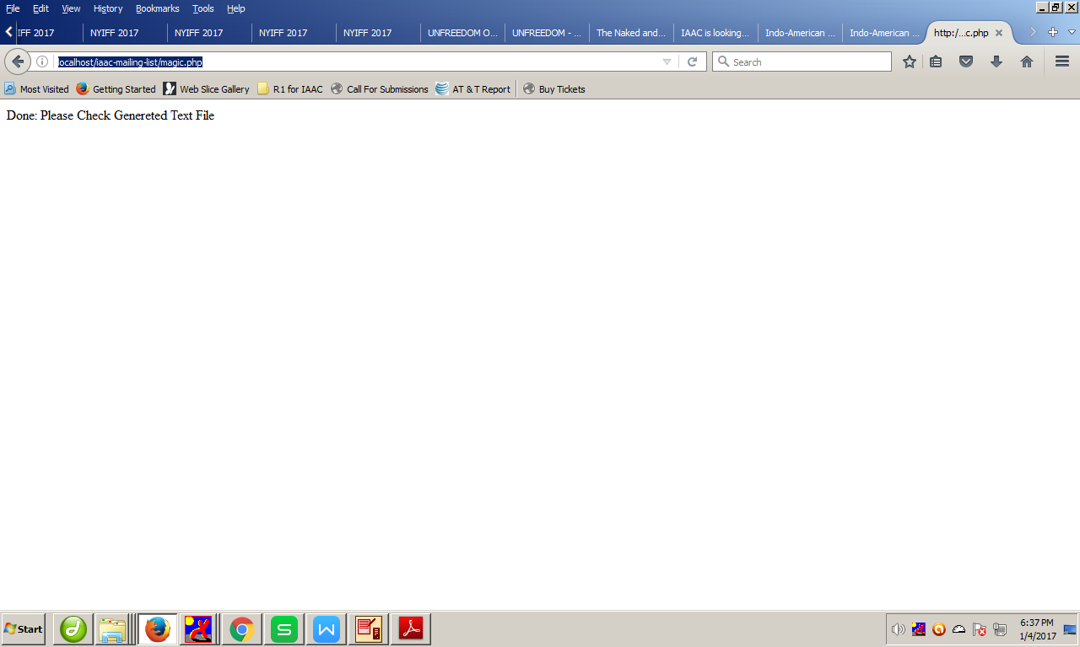

9. After few second list files generated in D:\wamp\www\iaac-mailing-list
Rename files with “date-0-to-2500.txt” name like
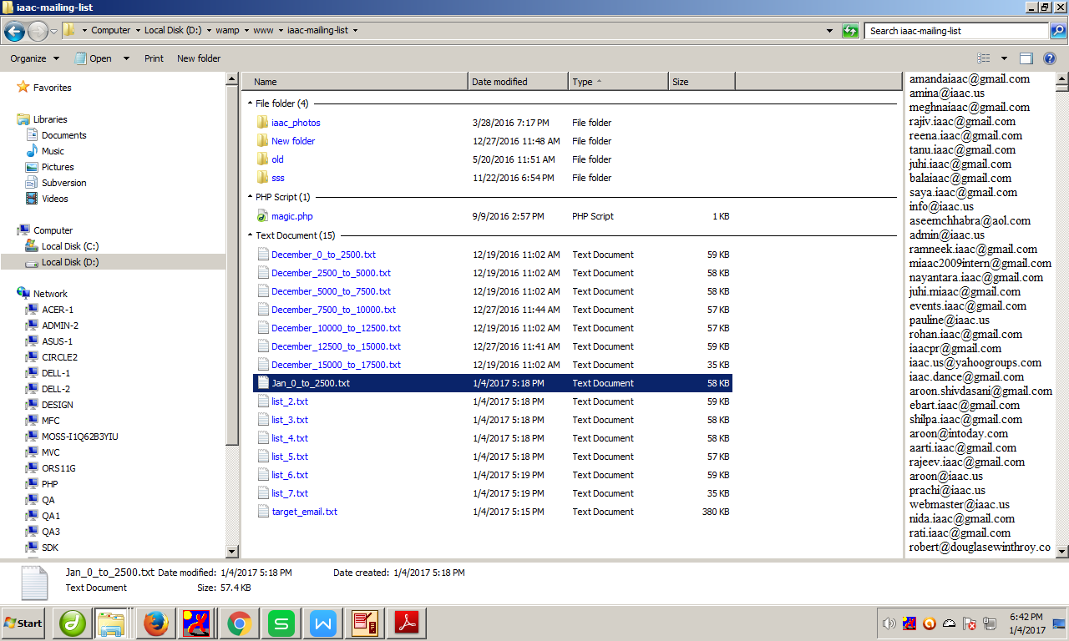

- Create new directory with “date-other.txt” name like
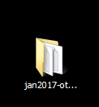

In that directory contain all list file which is generated file,rename files and exported file.
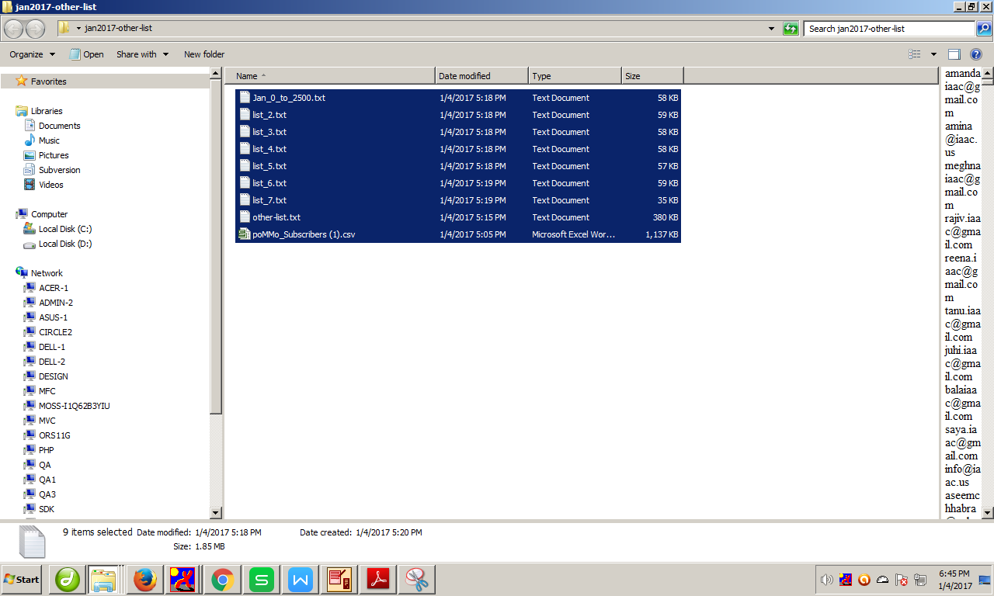

11. Finally share directory with sir.

